Apr 23 2016

Social Media and Network Mobile Application

Contract for Project Work Agreement
Prepared For
Mr. Adel Hasanat "The Client"

Preface
We are Scalsys Technologies "The provider" would like to propose this contract. We will alder by the details covered in this contract document of the project presented as under. Along with that, we have explained our approach towards development of such critical yet interesting applications.

Employees Involved in this project: The following are the employees who will work
full time on the project:
Graphic Designer: 2 graphics designers
Skills: Adobe, Photoshop, Illustrator, Dreamweaver.
Back end developers: 2 developers
Skills for backnd: yii2 PHP, Linex, Apache, API Integration.
Front end developers mobile : 6 developers
Skills: Android, iOS, windows
Qa and tester: 1 Tester

Project Requirements Overview
- Client wants to develop social media and networking Mobile applications following the industry standard in all modules and Mobile application security and performance.
- Mobile application allows users to communicate and gain knowledge.
- Mobile applications will allow the travelers or and other people with same interests to connect with each other.
- Mobile application will have a professional look & feel.
- Mobile application will be easily scalable.
- Mobile application Admin Control Panel “CP” will allow admin to perform any required task to manage, control, and monitor the Mobile application smooth operation and management.
- Contract document is prepared according to features list given by Client.

Total Design
In this stage, we transform detailed requirements into design of the front end, back end and Admin CP. Front end includes the total Mobile application design, backend define the database structure and coding needed for the system. Admin CP includes required task to manage and control the Mobile application.

Design and Development
Converts a design concept into a complete information system, includes but limited to acquiring and installing systems environments, creating and testing databases, preparing test case procedures, preparing test files, coding, developing, designing, compiling, refining programs, training client on the software, performing test readiness review and procurements activities.

Total Testing
Tests to demonstrate that developed system conforms to requirements as specified in the project details below. The tests will be conducted by our Quality Assurance staff. Tests will include Site Speed, Site Security, Bug Test Analysis Reports. In addition, we will perform tests during implementation and preparation of the total system into production environment and resolution of problems identified in the integration and testing each phase to Client satisfaction.

Cost
The cost to complete Travel Social Network and Media project, the Dating Social Network, Media project tentatively named OkPal.me and PalChat will be $15,000 paid by the Client based on the payment terms and milestones explained below in “point 8” that is independent of currency fluctuation. Travel Mobil App as outline below and following the foot steps of TravBud.com. OkPal will be following the foot steps of OkPal.me website and all items listed below but without the travelling flavour but a dating flavour. PalChat will be the third Mobil App which will include a login module, feed module, dashbroad module, all Whatsup functions including the messaging and VOIP ability and selecting functions of the Skype functions.

Project Silent Details:
- Framework: We will develop it using Yii2 framework and Nosql “DB Mongo” database for backend, Android and iOS for Front-end. We will ensure maximum utilization of the primary benefits of the MVC architecture, widgets and Web services extensibility, caching functions, DAO/Active Record, authentication and role-based access control, scaffolding I18N/L10N compliance. The final Mobile application design created by us will have all the features, capabilities and functions that are listed in the generalized list of the functions and modules below. The Mobile application look and feel will be unique and not in violation of any copyrights.

- Code: The code provided by us will be modular and well-organized and will not contain any encrypted files and work together cohesively. In addition, layout flowchart of scripts interconnections will be well documented. The code must be understood by Client programmers and by colleagues in case of future enhancement of functionalities. Also the code will be commented. Furthermore, the site will done professionally with a stable code; professional look and feel; solid security; initial site capacity of 10 million members and can easily expandable and scalable to around +20 million members. At the end, it means clean code, good client caching, little queries to database plus good server side caching.

- Outside services: We will develop all software, no outside services is required expect third party integration like hotel booking and others, unless agreed on upfront by the Client. This project will not rely on any services that require monthly (or other) fees or other services unless it is approved by the Client, i.e. no outside services, nor other software to buy. Client requires complete and fully-functional working program(s) in executable form as well as complete source code of all work done (so that Client may modify it in the future). Any custom code libraries or files needed to run the Client code will be provided to the Client along with final software. A backup copy of all deliverables is to be sent electronically to the Client by way of upload to the final server used for installation AND zip file will be sent via FTP.

- Software Right: All rights to this software belong exclusively to Client and we will provide 100% of the source code upon completion. We will not be able to sell or share to second or third parties or licensed out any part of any of this project code or design to anyone else. All deliverables will be considered "work made for hire" for the Client. Client will receive exclusive and complete copyrights to all work purchased as we sign Non Disclosures Agreement with the Client.

- Time Frame: The total project will be completed within 120 days window. We must stay within the stated time schedule. If we are beyond the total project deadline date or beyond for any milestone schedule window, Client reserves the right to void and null the agreement and get escrow funds back. Client will have live access to all code and servers during development. Client will have direct access to the full team, which is working on the project via: Phone, Email, Skype or any VOIP means.

- Installation Guideline: Any Mobile application server-side deliverables will be installed by us, we will move the software from the place it was created (QC environment) to the (production environment) in ready-to-run condition in the Client's environment. The Client will have number of front-end servers and database servers setup for software deployment. We will have to install all deliverables software once 100% completed on the beta servers keeping in mind load balancing for the front end server and the database server. We will recommend required OS or any other software versions needed to install the deliverables code. We will assist in servers set up and configuration for the initial deployment of the Mobile application.

- Testing: We will tests deliverables code/the software to make sure that the installation was done properly and completely in the production environment. The development phases will run in our servers and after completion of each phase we will upload the files to Client server. Client will have full access to site at our servers. While development we use our debug toolbar program that evaluates requests and queries to show their execution time and that helps developer to analyze if anything taking too long to load. We code automatic testing classes in the code to check for any bug in our code. PEAR-Benchmark- Running of the database queries with good accuracy and time efficiently

- Payments terms and milestones
Client will not pay provider directly nor pay provider upfront. Hence, client will post five equal payments in the portal Escrow account as work is completed for each milestone for the three social networks and media Mobile applications. Client will release fund to the provider own account once work for that milestone is completed for both Mobile applications as shown below in the table. Once payment is funded to the ESCROW account for any milestone, then any work for that milestone can be uploaded to client servers for further testing and verification during development of that milestone. Client will not accept partial work, only complete 100% working project.

Note: Multiple milestones can work in parallel to speed production

Milestone | Work Competed | Time | Cost
1 | Provider completes  - Kick start meeting: project discussion, Task management, project setup in, team roles and responsibility assignment  - Android and iOS Environment Setup  - Github repository setup  - Server setup with all necessary extensions and software and create document for it  - Design all screen for milestone 1, including popups with attractive front-end with responsive design  - Milstone 1 images design  - Splash Screen, Home page design and selected social media signup API connection  - Social media login through relevant API from provider like Facebook  - Registration and login process including sign up screen and photo upload  - User Login Options using Email id, Mobil, user id and password  - Forget password and remember my password  - Account verification process and Thanks for joining TravBud  - Admin notification on account creation  - User Detailed Profile management and profile editing as detailed in the project agreement below  - Profile completion progress as detailed in the project agreement below  - Account general setting as detailed in the project agreement below  - Account Security Management as detailed in the project agreement below  - Privacy on profile page, restriction for email, phone, birthrate,  - Privacy on content sharing setting as detailed in the project agreement below  - Live Newsfeed features through Travfeed Module and options as detailed in the project agreement below  - The Plus sign  - Gary bar  - Meters “Counters”  - Alert Notification  - Friend Requests  - Four columns in Travfeed Module engine design with menu column 1st, post column 2nd, misc column 3rd and friend list column 4th. Design should be based on new screens developed by ScalSys.  - Travfeed: feature for Sharing videos, photos, links, questions, location, poll on Travfeed engine  - Travfeed: targeted content sharing with different levels of privacy like public/friends/myself/custom  - Travfeed: privacy management for posts  - Travfeed: comments on post, hide additional comments to keep design visible  - Travfeed: Members can expand comments to display additional comments as needed  - Travfeed: like/dislike posts  - Travfeed share post and view the live feed/Posts shared from their friends  - Adapt tools to improve performance of newsfeed such as edit or delete or sort or save posts  - search Bar that allow member to search by people, places, group, company, pages..  - Dashboard futures and options as detailed in the project agreement below  - Dashboard: has the following tabs (Wall, Post, Gallery, Contributions)  - Dashboard: items in the Wall page are (friends, photos, likes, travel destination, referrals, endorsements)  - Member should be to manage( view, edit, delete, update and ad) their Wall page items  - Dashboard: items in the Post tab are all post done by the member and members friend posting on the page  - Member should be to manage ( view, edit, delete, update and add) their Post page items  - Member can share videos, photos, links, questions, location, poll on their Post page  - Dashboard: items in the Gallary tab are all photos posted by the member the Gallary module  - Member should be to manage ( view, edit, delete, update and ad) their Gallery page items  - Dashboard: the Contributions tabs shows activities by the member such as num. of blogs, review, photos profile views and more  - member can see who visited their profile page  - Member can add a Friend, also add friend from his Email  - Send Friend Request with short message to other users and receive friend request option  - Follow other Users and get notifications from there  - See the contact details of other users  - Visit the profile of other users  - Member can mute his friend list  - Visit the profile of other users and see public detail  - User can report abuse for any unknown users  - Security and speed testing  - File system setup i.e. folder and sub dir for photo, doc..  - Upload Milestone 1 and test on client servers with client team  - Cross Learning (Detailed Project Communication)  Testing and delivery | 50 days | $3000  Include the cost for Travel Modil App and Okpal.me Mobil App and PalChat of milestone 1
2 | Provider completes work for  - Design all pages for milestone 2, including popups with attractive front-end with responsive design  - Who is around module\ List who is online, popular, around me, birthdates today and friend request..  - Who is around module: members can send message,  - Message system thread style\ Send message, archive, block thread, trash, search message, message counter  - messages with options to send ecard, egift and post card  - Real-time chat system and options integated with the messaging system  - Notification on activities  - Community Event\ Create, update, del share event, get details about users who join events, invite people to event, setup meeting date and location, invite/ join  - Group\ Create, manage, del, update, joint group, intive to group, view group …  - Group newsfeed: Post Message, group posting, Images, Videos share, update, like, comment…  - Photography: Public Gallery upload photos and listing with options  - Traval Buds\ members can advert and send message to each other to do joint trip to certain destination  - Keep n Touch module , as detailed in the project agreement below  - Local Hosting module allow member to find host at the destination country  - User can search using City, Zip code or click in Meets locals  - Travel business Wall Page setting as detailed in the project agreement below  - Travel business Wall Page tabs and items as detailed in the project agreement below  - Business Services link  - Subscribe for newsletter option  Testing and delivery | 50 days | $3000  Include the cost for Travel Modil App and Okpal.me Mobil App and PalChat of milestone 1
3 | Provider completes work for  - Design all pages for milestone 3, including popups with attractive front-end with responsive design  - Hire a guide Module as detailed in project agreement below  - Travel stories "blog" with option\ Create Blog, share blog, make comments, like, share, rate  - Travel experiences: Member can share travel experiences with their friends or public  - Travel Helper module \ Create a thread, search, share, like. make answer on particular question, rate  - Travel tips \ User can get travel tips from different travellers  Testing and delivery | 40 days | $3000  Include the cost for Travel Modil App and Okpal.me Mobil App and PalChat of milestone 1
4 | - VIP members modules  - Credit reward point module  - Billing module  - Advertisement module  Testing and delivery | 40 days | $3000  Include the cost for Travel Modil App and Okpal.me Mobil App and PalChat of milestone 1
5 | Post delivery, this is a critical aspect of the project, as many issues will arise once the website goes LIVE. We want to have a developer on standby for immediate support to jump over any problem that might arise. After the successful closing of the first month-end in production, We will conduct a post-implementation review to assess how well the production system has met the business objectives set at the beginning of the project. In addition, we will review the independent third party engineers report and alder to their recommending how the site is running. | 90 days | $3000  Include the cost for Travel Modil App and Okpal.me Mobil App and PalChat of milestone 1

Pal Chat: Messaging Application Android & iOS
No. | Feature List
1 | Splash Page
2 | Option to create user account and login via email or Mobil num with a password.
3 | Registration via Facebook
4 | Profile Update, Status Update, Photo Update and privcey setting, billing setting.
5 | Add, Block contact similar to whatsup or a User similar to SkyPe,
6 | Contact List using Mobil contact and User ID
7 | Media Messaging (Text, Video, Image) similar to whatsup
8 | VOIP calls similar to whatsup
9 | Feeds (Facebook, Twitter, Instagram, Linkedin)
10 | Live Feeds Sharing, Like, comment
13 | Ads ability and billing
14 | Set Preferences
15 | In-App Purchases (Sticker etc)
16 | Log Out
17 | Data Backup

- Support: We will provide six months free support after the site is live on ERRORS, BUG Fixes and MAINTAINANCE on the live Mobile application delivery that includes training client staff. Client will have to sign up contract to maintain the site after the free support elapse. All new feature requests are done at $xxx per hour or on a fixed price basis based upon the scope of the feature.

- Training: We will provide ongoing training to the Client project manager on modules while in the developing stages, go over code file and mythology of the project; answer any question that Client will have. Train the Client project manager on the code to be able run update or manage modifications on any section in future. In addition, we will provide to the Client any test report in form of document or print out as well provide the client with
            - Excel sheets with database structure fully documented will provided to Client.
            - Create and teach Client how to create flat text file of database.

- Document: We will create a document describing everything the final Mobile Application will do (other than what was documented in the prototype). In addition, we provide help manual to support the help section in the final Mobile application.

- Testing Environment Setup: We will have three testing environments setup for this Project, the Client will have live access to the testing setup:
- Local Development (internal team).
- Staging (to show and tell us).
- Production (To simulate Client environment with two front end servers and two database servers hardware. One server to be setup for the master database and the other server to be setup for the slave database with fail over, real-time sync and life hits).
- Our testing will include:
  - Automatic code testing
  - Functionality Testing
  - Usability testing
  - Interface testing
  - Compatibility testing
  - Performance testing
  - Security testing
  - Stress testing of the site with report will be showed to the client.

- Regular Updates: We will provide regular update and feedback to the Client; every module will be tested rigorously to ensure quality, reliability, scalability and usability with speed load. The fine points will be worked out to the Client satisfaction. At the end of the day, we will email Client a brief daily update about work completed on the project. Client will have access to the development environment and servers to allow Client to view and evaluate work completed.

None-Disclosure Agreement:
We "The Provider" acknowledge that, this project detail is confidential information and is the proprietary and property of the Client. We hereby agree not to directly or indirectly compete with the proposed business of the project discloser. We recognize and acknowledge that the information have competitive value. Hereto, unless expressly stated otherwise nothing contained in this project detail to be used, can be used, nor may be relied upon or shared with any other party, unless approved by the Client. We are hereby been notified that any dissemination, distribution or copying of this project detail is strictly prohibited. This project detail is intended only for the person(s) to whom it is addressed and/or otherwise authorized. We acknowledge that copying, printing and disseminating any information related to this project detail is prohibited.

This agreement herein entered between Scalsys Technologies "The Provider" and Adel Hasanat "The Client" in Jan 07, 2016. The Provider will develop the Client projects concept to fully working Travel Social Network Mobile application and Dating social networks and media Mobile applications as outlined in both contracts. Both parties agreed to alder with all the points listed above in this contract and agree to enter in this agreement.

The Client/Project Manager
Adel Hasanat

Screens ( For Rerefence only aka wireframes)

Splash Screen
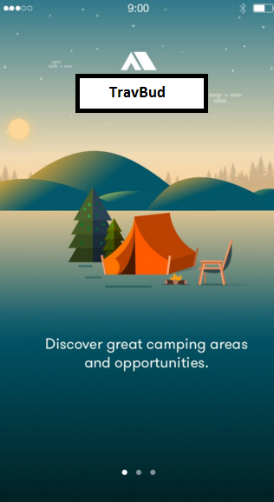

Login
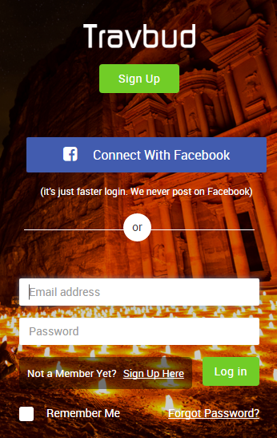
Signup

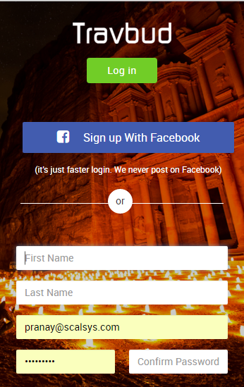

NewsFeed

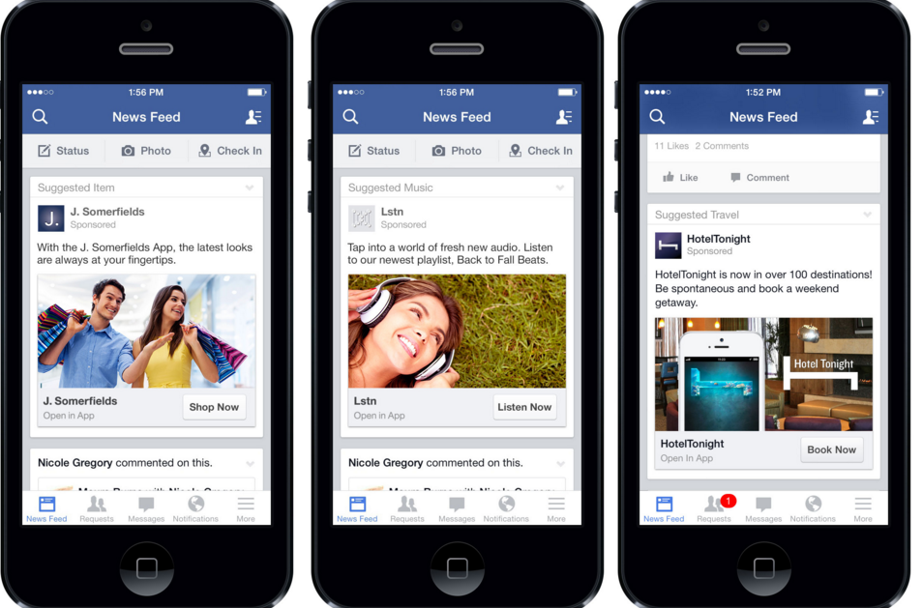

Add Post
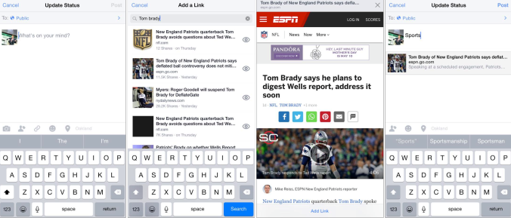

Comment Post

Menu Items

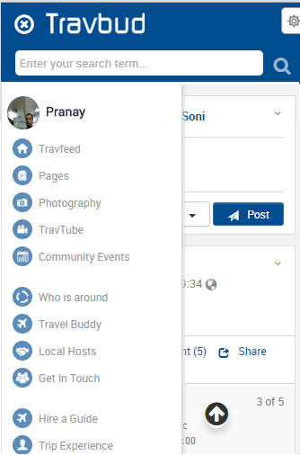

User Profile
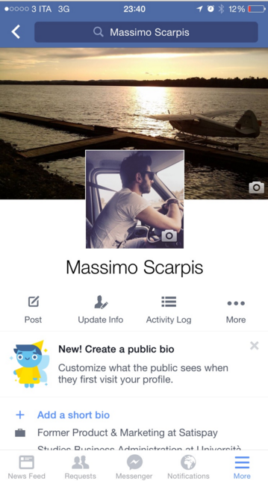

Delete pot

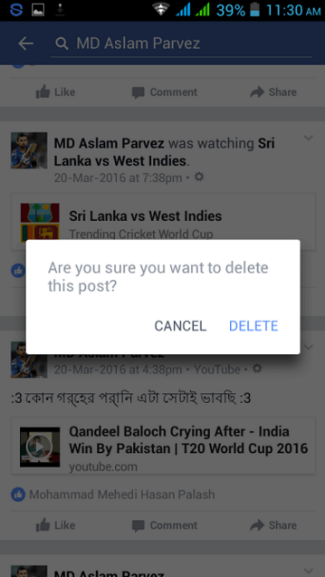

Friend request
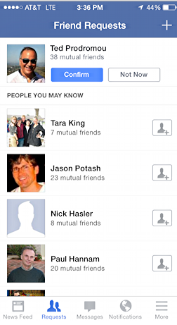

Image Gallery

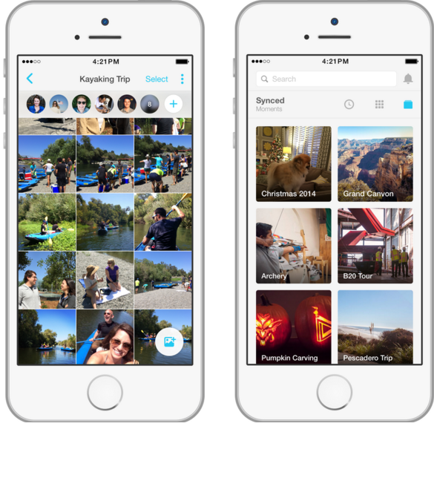

Chat:

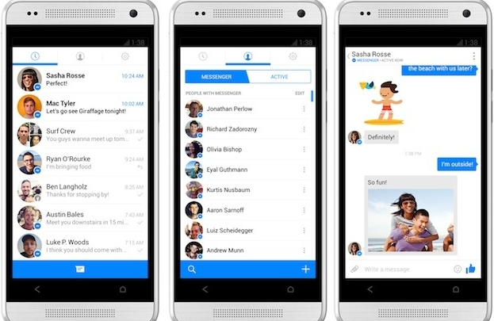

Share
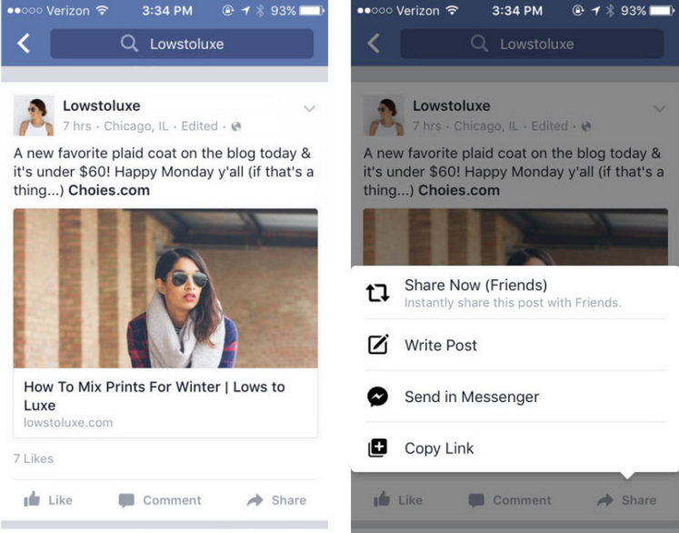

Note:
- Above screens are reference only. Design and structure may wary as per new creative design.
- Above screen will cover all social activities design wireframes.
- Other screens for travel buddy, hire a guide and other will be followed by portal design. Approval will needed from customer side for each design.

